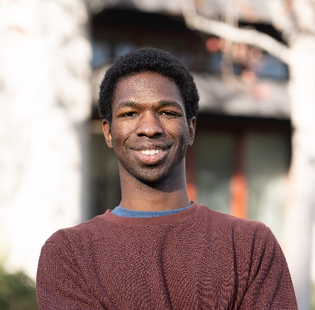Kenton Guarian
Kenton.Guarian@gmail.com | (619) 550-6378 | San Diego, CA | LinkedIn
Results-driven Mathematics-Computer Science graduate from UC San Diego with hands-on experience in developing machine learning solutions, data wrangling, and automated dataset generation. Proficient in designing scalable platforms and implementing data-driven approaches to improve accuracy and efficiency while reduce costs. Passionate about leveraging technical and interpersonal skills to find and tell the story the data holds.

Technical Skills

Programming Languages: Python, SQL, JavaScript, HTML, Go.
- Data Science Tools: NumPy, Pandas, Scikit-Learn, PyTorch, Jupyter Notebooks
- Data Science Techniques: Deep Neural Networks, Digital Signal Processing, Data-driven research.
- Soft Skills: Collaboration, Communication.

Professional Experience
UC San Diego – La Jolla, CA
Machine Learning Engineer, Department of Cognitive Science
Mar 2021 – Present
- Trained a deep learning model to identify key brain signals with 98% accuracy, setting a new benchmark for accuracy and precision.
- Designed a patent-pending algorithm to parametrize heart signals, achieving a 1000x increase in processing speed.
- Developed a secure data collection platform, improving research efficiency by 30% while reducing annual operating costs by $3,000.
- Published quantitative research in Oxford SLEEP Journal and Alzheimer’s & Dementia Journal, contributing to the field of predictive healthcare.
Mechanical Music Digest (MMD) – San Diego, CA
Software Engineer
Oct 2020 – Mar 2021
- Engineered AI-driven algorithms for real-time behavioral monitoring, enhancing user experience and engagement.
- Automated compliance checks within backend workflows, reducing errors and manual intervention.
- Co-developed an automated newsletter distribution system, improving system uptime and scalability.
- Built extensions for VirtualDJ, incorporating security protocols for safe playback and data integrity.
UC San Diego – La Jolla, CA
Front-End Developer, Department of Computer Science
Jun 2021 – Sep 2021
- Built a serverless code execution platform, reducing infrastructure costs by 100% and enhancing scalability.
- Integrated secure on-device code execution protocols to mitigate vulnerabilities in distributed systems.

Education
UC San Diego – San Diego, CA
Bachelor of Science in Mathematics-Computer Science
Sep 2019 – Dec 2023
- Honors: PATHS Scholar, Golden Pyramid Scholar, Research Methodologies Training Laboratory Fellow, Provost Honors.

